Module 11:

Communicating Project Information

Contents

Module Overview 1

Lesson 1: Defining Print Settings 2

Print Settings 3

Define Page Setup 8

Copy Picture 13

Practice: Working with Copy Picture 15

Lesson 2: Working with Project Reports 16

Selecting Project Reports 17

Editing Project Reports 20

Creating Custom Project Reports 26

Practice: Creating a Custom Project Report 29

Lesson 3: Working with Visual Reports 30

Overview of Visual Reports 31

Anatomy of a Pivot Table 34

Viewing Visual Reports 36

Creating Visual Report Templates 38

Practice: Viewing and Creating Visual Reports 42

Lesson 4: Collaborating Project Information 43

Export Project Table to Excel 44

Publish a Project to SharePoint List 50

Import SharePoint List into Project 52

Video Demo: Working with SharePoint 54

Practice: Exporting Project Data to Excel 55

Summary 56

11

.

# Module Overview



Sharing project information and status is the responsibility of the Project Manager. Project 2010 offers an abundance of reporting options for users. Many standard reports are available and can be customized for specific use.

In this module, we will discuss:

* Print options and settings
* Standard and customized reports
* Visual Reports
* Exporting project data
* Publishing and importing project data to SharePoint lists

# Lesson 1: Defining Print Settings



Most of the print settings in Project 2010 are similar to other Microsoft Office products. Unique to Project 2010 is the ability to include project and task data in report titles using the header and footer options. Printing Gantt charts on paper or using Gantt charts in presentations will also be discussed in this lesson.

In this lesson, we will discuss:

* Print Settings
* Define Page Setup
* Copy Picture

## Print Settings



Project 2010 gives you the ability to customize how a report will be printed. Seeing the final report before it is printed assures the user that they are printing the correct report. Print options allow the user to select a printer and fine-tune which data will be printed. When the print options are selected, the current active project view will be printed.

**To display print settings options view:**

* File 🡪 Print

**To close print settings options view:**

* Click any tab above the ribbon bar

Below is a view of the print option screen. When the options were selected, the Gantt Chart was the active view. On the left side of the view, several options are available:

|  |  |
| --- | --- |
| **Option** | **Action and result** |
| Print | Sends the report to the selected printer. |
| Copies | Determines the number of copies that will be printed. |
| Printer | Clicking the arrow on the right side of the box will open a drop-down menu and display all available printers. |
| Printer Properties | Clicking on the link will display additional printing properties. |

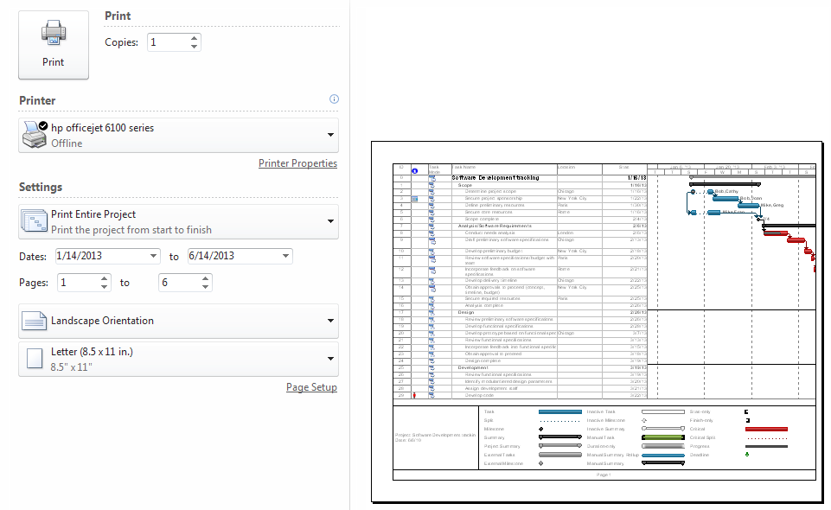

Click the down arrow on Settings to display more options to further refine the final printed report. These options are:

|  |  |
| --- | --- |
| **Option** | **Action and result** |
| Print Entire Project | Default value. The entire project schedule will be printed using the current view. |
| Print Specific Dates | Only the data between the date range will be printed. This option is not available for all reports. |
| Print Specific Pages | Select specific page numbers to print. |
| Print Custom Dates and Pages | Date range and page number range will be printed. |
| Notes | Add the project notes to the printed report. Notes will be printed on a separate notes page. |
| All Sheet Columns | When selected, all columns within the current view will print. |

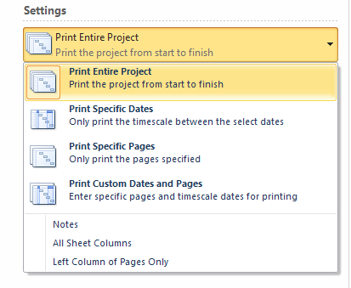

Page orientation and paper size options are also available.

Viewing options to preview the final report are available by clicking on the buttons below the active project view in the lower right corner of the screen. The buttons are shown below.

|  |  |  |
| --- | --- | --- |
| **Button** | **Represented by** | **Result** |
| Left arrow |  | Move one page to the left. |
| Up arrow |  | Move one page up. |
| Down arrow |  | Move one page down. |
| Right arrow |  | Move one page to the right. |
| Actual size view |  | Actual size of printed report. Use sliders to see the entire page. |
| One page |  | Report will show one page at a time. |
| Multiple pages |  | Report will show in multiple page format. |

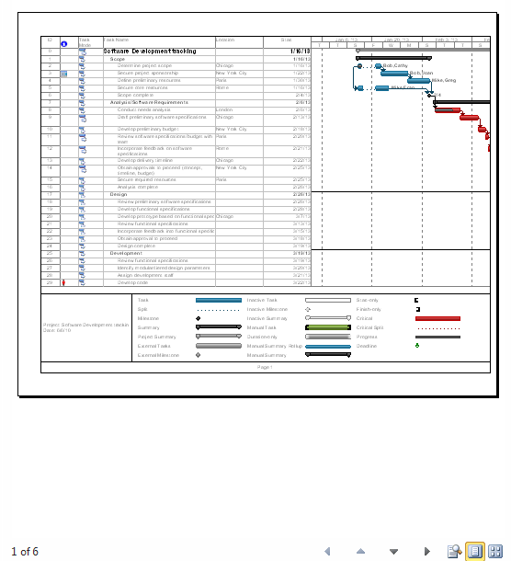

**TIP**: Add the Print Preview button to the Quick Access Toolbar:

• Click on the down arrow on the right side of the Quick Access toolbar

• Select **Print Preview**

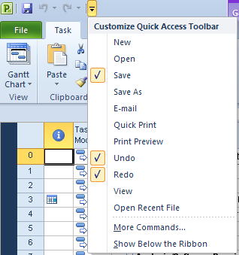

## Define Page Setup



Page setup options are similar to options available in other Microsoft Office products. Project 2010 has some unique options specifically for the types of views available in the application. These unique options will be discussed in this lesson.

Project level data may be entered for project name, author, company, etc. and applied to the project header and footer information. This information is entered using the Advanced Properties dialog box. Once the data has been entered, the header and footer information is configured per report using the Page Setup options.

**To add information in the Advanced Properties dialog box:**

* File 🡪 Info 🡪 Project Information 🡪 Advanced Properties

The dialog box is shown below:

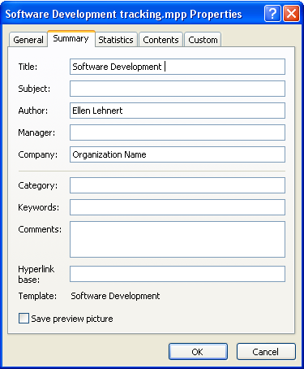

**To display the Page Setup dialog box:**

* File 🡪 Print 🡪 Page Setup

A dialog box will appear with the Page tab displayed. The options on this tab are similar to other Microsoft Office applications. The Margin tab contains the margin settings for the current report and an option to print borders around the data. Adjust these values as needed. The Header and Footer tabs allow for configuration of titles and footer information for reports. The view below shows the Header tab used for adding the project title values.

**To add Header or Footer information to the title of a project:**

* Click the **Header** or **Footer** tab.
* Click on the **Left**, **Center**, or **Right** tab in the lower section of the box.
* Click the down arrow to view the General drop-down menu.
* Select field value.
* Click **Add.**
* Repeat for additional data.

**TIP:** The Header and Footer settings are unique per report and should be checked using Print Preview before each reported is printed.

**Best Practice:**  A current date is not preset to show in either the header or the footer title lines. Add the system’s date using the center button above the General drop-down menu.

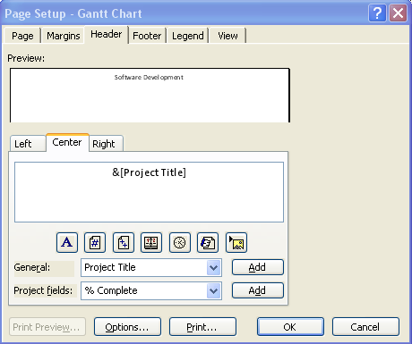

The Legend tab is used to customize or turn off the legend printed on Gantt charts. If unique Gantt chart formatting has been created, the alternate color coding will automatically appear in the legend when the Gantt chart is printed. The Legend Labels button allows for font color and font selection changes. To disable the legend printed on Gantt charts, select None on the right side of the dialog box .

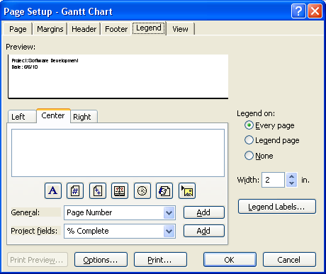

The View tab contains options for specific views, but not all options will be available for each report. The options on the View tab are:

|  |  |
| --- | --- |
| **Option** | **Result of selecting option** |
| Print all sheet columns | All columns in the table of the active view will be printed. |
| Print first (enter number) columns on all pages | Specify the number of columns to be printed on all pages of the report. When printing a Gantt chart, it is advantagous to add the task name to all pages. |
| Print notes | A separate notes page will be added to the report. Task ID numbers will be used to tie the note to the task. |
| Print blank pages | When printing Gantt charts, blank pages might result. Should these pages be printed? |
| Fit timescale to end of page | Adjusts the timescale for the report. |
| Print row totals for values within print date range | Adds totals to Resource Usage and Task Usage reports. |
| Print column totals | Adds totals to Resource Usage and Task Usage reports. |

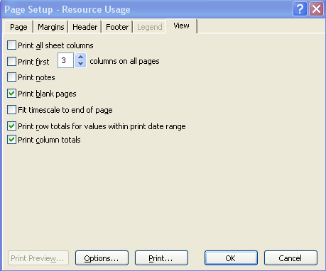

## Copy Picture



Use the Copy Picture tool to take a picture of your active view and store it on the clipboard. After it is stored, it can be pasted into Powerpoint, Word, Excel or any other application. The Copy Picture button, by default, is not available on any of the ribbon bars, but it can easily be added to the Quick Access Toolbar.

**To add the Copy Picture tool to the Quick Access Toolbar:**

* Click the down arrow to the right of the Quick Access Toolbar.
* Select **More Commands.**
* Under Choose commands from Popular commands in the left box select, **Copy Picture.**
* Click **Add.**
* Click **OK** to close.



The copy picture icon looks like this:



To use the Copy Picture tool, the view must be displayed and refined for the picture. Navigate to the view to be copied. Some adjustments to a view might include:

* Expand or collapse the work breakdown structure.
* Adjust timescale.
* Adjust titles in the timescale.
* Change formatting.
* Highlight tasks.
* Add drawing elements.

If printing a Gantt chart, adjust the vertical bar in the middle to show the columns to be included and click **Copy Picture** to open the Copy Picture dialog box shown below.

* **Render image** - select image to render For Screen, For Printer or To GIF image file.
* **Copy** - rows on screen or Selected rows.
* **Timescale** - as shown on the screen or date range.
* Click **OK** to copy to the clipboard.

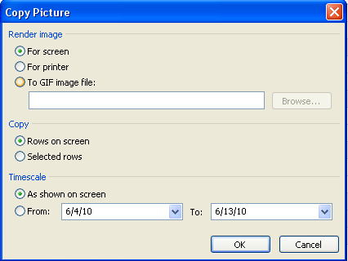

Use the image to paste into a Powerpoint presentation, a Word document, an email or other application. After pasting, resize the image as necessary.

## Practice: Working with Copy Picture



*The Practice page is where you write detailed instructions for completing work listed as Exercises.*

*Type the Exercise Title and write a brief summary what the student will be doing in the exercise. Then list your ideas what they will be doing.*

*SAMPLE*

*In this practice you will create a Project Server Authentication profile and then configure the local cache settings in Project Professional 2007.*

*Exercise 1: Create Project Server Authentication Profile*

*In this exercise you will create Project Server authentication profile to connect to the Project Web Access site.*

Perform the following exercise on the PS07 virtual machine.

1. *From the* ***Start*** *menu, click* ***All Programs*** *🡪* ***Microsoft Office*** *🡪* ***Microsoft Office Tools*** *and click* ***Microsoft Office Project Server 2007 Accounts****.*
2. *In the* ***Project Server Accounts*** *dialog box, click* ***Add****.*
3. *In the* ***Account Properties*** *dialog box, complete the following settings and click* ***OK****.*

|  |  |
| --- | --- |
| *Setting* | *Perform the following:* |
|  | |
| *Account Name* | *Type* ***Project Server*** |
| *Project Server URL* | *Type* ***http://epm/pwa*** |
| *When connecting* | *Select* ***Use Windows user account*** |
| *Set as default account* | *Select check box* |

# Lesson 2: Working with Project Reports



Communication is an essential part of project management. Project 2010 provides an abundance of textural reporting options to fulfill the communication requirements needed to help you manage your projects and communicate status to stakeholders.

In this lesson we will discuss:

* Selecting and understanding reports available
* Editing reports
* Creating a custom report

## Selecting Project Reports



Project 2010 provides numerous text-based reports to choose from to convey information relating to the project schedule, costing, resources, and assignments. Graphical reports are also available and will be discussed in the next lesson. Selecting the suitable report for a situation may sometimes be confusing. In this lesson, we will take a look at the types of built in reports that come with Project 2010.

There are 4 types of built in text-based reports available:

* Task
* Resource
* Cross-tab (information which will include assignments and time increments)
* Calendar

**To open the Reports dialog box:**

* Project 🡪 Reports
  + The box below will be displayed. Double click on a report category will display report choices

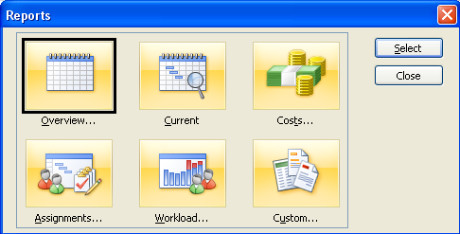

Task and Resource reports are based on tables and have the ability to apply filters. Each report has options to help customize the report for your needs. Many of the reports will also have access to the date range option available in the print option window. The reports are described in the tables below.

**Overview**

|  |  |
| --- | --- |
| **Report** | **Usage** |
| Project Summary | Quick snapshot of project statistics. |
| Top Level Tasks | Outline level 1 Summary tasks. |
| Critical Tasks | List of critical tasks. |
| Milestones | List of Milestones. |
| Working Days | Days and times on Project Calendar. |

**Current**

|  |  |
| --- | --- |
| **Report** | **Usage** |
| Unstarted Tasks | Lists tasks that have not started. |
| Tasks Starting Soon | Lists tasks within a specific date range. |
| Tasks in Progress | Lists tasks that have started but have not been completed. |
| Completed Tasks | List tasks that have been completed. |
| Should Have Started Tasks | List tasks that have not started but were scheduled to start. |
| Slipping tasks | Use this report only when a baseline has been set. All tasks where the planned finish is greater than baseline finish are considered to be slipping. |

**Costs**

|  |  |
| --- | --- |
| **Report** | **Usage** |
| Cash flow | Cost requirements spread over time. |
| Budget | Compares baseline costs against actual costs. |
| Overbudget Tasks | Compares baseline costs against actual costs where actual cost is greater than baseline cost. |
| Overbudget Resources | Compares baseline resource costs against actual resource costs where actual resource cost is greater than baseline cost. |
| Earned Value | Comparison of Earned Value metrics. |

**Assignments**

|  |  |
| --- | --- |
| **Report** | **Usage** |
| Who Does What | Lists resources and their assignments. |
| Who Does What When | Lists of resources and their assignments grouped by timeframes. |
| To-do List | Resource list of assigned tasks sorted by timeframe. |
| Overallocated Resources | List of resources assigned more work than their resource calendars will allow. |

**Workload**

|  |  |
| --- | --- |
| **Report** | **Usage** |
| Task Usage | Lists tasks, resources assigned to them and timeframe scheduled. |
| Resource Usage | Lists resources, tasks assigned to them and timeframe scheduled. |

All of the above reports have access to customization options when generated. The remaining category, Custom*,* offers the same list of reports outlined above. These report copies are designed to be copied and configured by the project manager. The reports in the Custom section may be saved by copying the report into the Organizer.

**To generate a report:**

* **Project 🡪 Reports.**
* Double-click on the category for the report.
* Click the report selection.
* Click **Select.**
* The report will appear in Print Preview.

## Editing Project Reports



Making changes to existing project reports or editing has many advantages. Tailoring a report to suit your needs will enable you to focus the report to the needs of your stakeholders and deliver a more effective communication tool. All changes that are made will be saved with the project schedule to allow repeat usage.

As mentioned in the previous lesson, reports are task-based, resource-based or crosstab. A crosstab report is defined as a report which will include assignments and time increments in addition to Task or Resource information. Task and resource-based reports are edited similarly with crosstab reports treated differently. Both types of reports will have some of the same editing capabilities.

The following steps are an example of editing the Unstarted Task report.

**To edit a Task or Resource report:**

* **Project 🡪 Reports.**
* Double-click **Current Report**
* Click **Unstarted Task** report.
* Click **Edit.**

The Task Report dialog box open with the Definition tab showing:

**Definition**

|  |  |
| --- | --- |
| **Field** | **Options** |
| Name | Standard report name, may be altered |
| Period | Time period for the report. |
| Count | If time period is in weeks, 2 would be every other week. |
| Table | Any tasks standard or custom table may be used. |
| Filter | Any tasks standard or custom filter may be used. |
| Show summary tasks | Optional. |
| Gray bands | Places bars across report as guides for easy reading. |

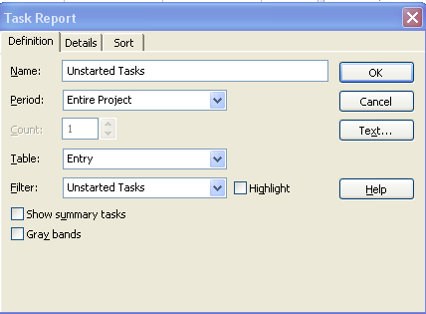

**Details**

|  |  |
| --- | --- |
| **Field** | **Options** |
| **Task** | |
| Notes | Include task notes in the report. |
| Objects | Print any objects that are contained in the notes field. |
| Predecessors | Include Predecessor information. |
| Successor | Include Successor information. |
| **Assignment** | |
| Notes | Include assignment notes in the report. |
| Schedule | Include resource schedules in the report. |
| Cost | Include assignment costs. |
| Work | Include assignment work information. |
| Border around details | Formatting. |
| Gridlines between details | Formatting. |
| Show totals | Totals will be shown for work and cost columns only. |

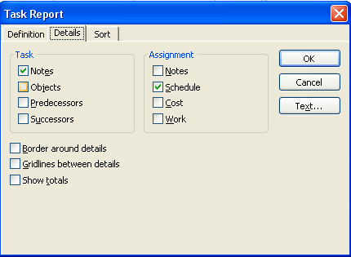

**Sort**

Reports can be sorted at 3 levels using either standard or custom fields. The fields by which the data is sorted does not have to be included in the table that is printed. At the bottom of the box is an option to keep the outline stucture of the data after the sort has occurred.

On the right side of the box is an option for “Text”. This option allows for application of Text Style formatting for the report. “Reset” will reset the report definition to the original values.

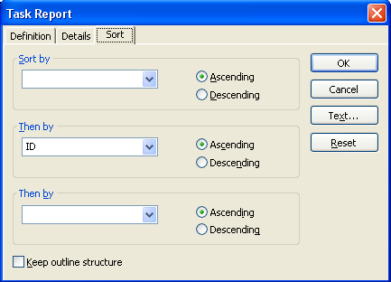

After editing changes have been made:

* Click **OK** to close the Task Report dialog box.
* Click **Select** to Print Preview the new settings in the report.

Crosstab reports have different options. In this example, changes will be made to the Who Does What When report:

**To access report definitions:**

* **Project🡪 Reports.**
* Double-click **Assignments.**
* Click **Who Does What When**.
* Click **Edit.**

The Crosstab Report dialog box will open.

**Definition**

|  |  |
| --- | --- |
| **Field** | **Options** |
| Name | Standard report name. |
| Column | Time period for the report. Days, weeks, months, etc. |
| Row | Resources or Tasks. |
| Field value | Value field: Work, costs, etc. |
| And task assignments | Optional. Default for this option is ‘On’. |
| Filter | Any standard or custom resource filter. |
| Highlight | Highlights filtered data. All data will be viewed on the report. |

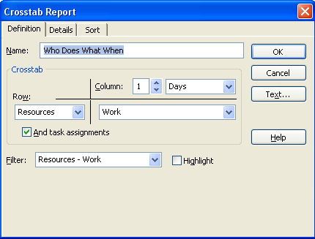

**Details**

|  |  |
| --- | --- |
| **Field** | **Options** |
| **Show** | |
| Summary tasks | Available for task-based reports only. |
| Row Totals | Work and cost totals only. |
| Column Totals | Work and cost totals only. |
| Gridlines |  |
| Between tasks | Optional formatting. |
| Between resources | Optional formatting. |
| Show zero values | Optional. |
| Repeat first column of every page | Description will be printed on every page. |
| Date format | Select the format for the date for the report |
| Text | Apply Text Styles to data. |

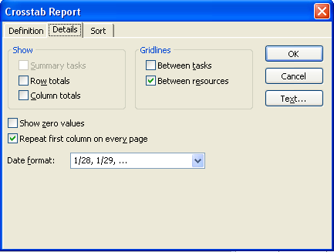

**Sort**

The sort tab is very similar to the previously mentioned task report sort options. Notice the Sort resources by project option highlighted below. Reports can be generated across multiple projects.

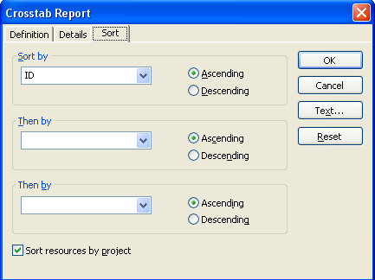

## Creating Custom Project Reports



Creating custom reports is a simple process, very similar to the editing report features in the previous lesson. Custom reports can be copied using the Organizer.

The steps to create a custom report are as follows:

1. Decide which report you would like to customize.
2. Select a report template and copy it or create a new report.
3. Make editing changes.
4. Save the report using the Organizer for use with other project schedules.

In the example below, a new task report will be created.

**To create a new task report:**

* **Project 🡪 Reports.**
* Double click **Custom Reports**.
* Click **New.**

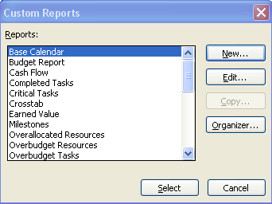

* + The Define New Report dialog box will display. Choose from Task, Resource, Monthly Calendar or Crosstab report type. In this example, Task was selected. Click **OK**.

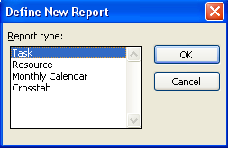

The Task Report dialog box opens.

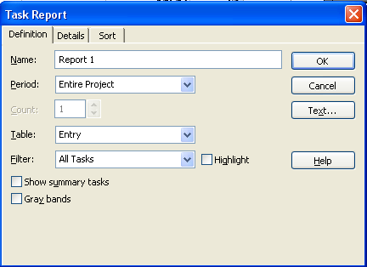

* + Enter a unique report name and select other report parameters as previously discussed in this module. Click OK to complete the report.

When the definition is completed, the new report will appear in the list of Customized reports. In the example below, a new report called New Task Report was created and can be seen in the list of reports.

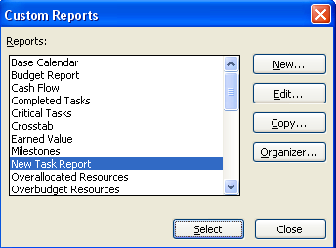

**To run the report**:

* Double **New Task Report.**

OR

* Click **New Task Report.**
* Click **Select**.

The New Task Report was created for the current project schedule.

To save the report for future use in other project schedules:

* + Click the **Organizer** button to open the Organizer dialog box
  + Click **New Task Report** in the current project in the right pane and click **Copy** to copy the report into the Global.mpt.

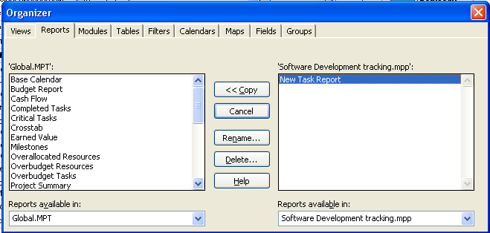

## Practice: Creating a Custom Project Report



*The Practice page is where you write detailed instructions for completing work listed as Exercises.*

*Type the Exercise Title and write a brief summary what the student will be doing in the exercise. Then list your ideas what they will be doing.*

*SAMPLE*

*In this practice you will create a Project Server Authentication profile and then configure the local cache settings in Project Professional 2007.*

*Exercise 1: Create Project Server Authentication Profile*

*In this exercise you will create Project Server authentication profile to connect to the Project Web Access site.*

Perform the following exercise on the PS07 virtual machine.

1. *From the* ***Start*** *menu, click* ***All Programs*** *🡪* ***Microsoft Office*** *🡪* ***Microsoft Office Tools*** *and click* ***Microsoft Office Project Server 2007 Accounts****.*
2. *In the* ***Project Server Accounts*** *dialog box, click* ***Add****.*
3. *In the* ***Account Properties*** *dialog box, and complete the following settings and click* ***OK****.*

|  |  |
| --- | --- |
| *Setting* | *Perform the following:* |
|  | |
| *Account Name* | *Type* ***Project Server*** |
| *Project Server URL* | *Type* ***http://epm/pwa*** |
| *When connecting* | *Select* ***Use Windows user account*** |
| *Set as default account* | *Select check box* |

# Lesson 3: Working with Visual Reports



Visual reports are graphical type reports that are available in Project 2010. These reports are defined using a template in Project 2010 and use either a Visio PivotDiagram or Excel PivotTable technology to generate the final report. Once a report is generated, changes and fine-tuning of the report can be performed through Visio or Excel.

Since Visual Reports use Pivot table technology, knowledge of Pivot tables is helpful for the project manager to gain the greatest benefit from these reports.

In this lesson we will discuss:

* + Overview of Visual Reports
  + The Anatomy of Pivot Tables
  + Viewing a Visual Report
  + Creating a Visual Report template

## Overview of Visual Reports



Visual Reports are reports based on dimensions and measures that produce graphs using Pivot Tables. Pivot Tables will be discussed in the next lesson. When a Visual Report is run, an On-line Analytical Processing (OLAP) cube of data is built based on the metrics stated in the specifications for the Visual Report. After the cube is built, Project 2010 connects to either Visio or Excel to display the report. If an Excel-based report is selected, the report will be based on Pivot Tables. If a Visio-based report is selected, a Visio Pivot Diagram will be produced.

Once a report is generated, it can be manipulated as a Pivot Table and tailored to fit your needs. Types of manipulations include expanding and contracting outline levels, changing field values, selecting options, adding totals and changing the appearance of graphs. After the Visual Reports are generated, they can be saved or published to a reporting website.

Project 2010 provides multiple Visual Report definition templates found in the Visual Reports - Create Report dialog box. Options are available to filter the Excel templates from the Visio templates. All templates are contained in the All tab within the dialog box.

Sub tabs are provided for various report categories, and contain the following report options:

**Task summary tab:**

|  |  |  |
| --- | --- | --- |
| **Report** | **Content** | **Excel or Visio** |
| Critical Tasks status report (Metric) | Work and Work remaining for critical and non-critical tasks. | Visio |
| Critical Tasks status report (US) | Work and Work remaining for critical and non-critical tasks. | Visio |

**Resource summary tab:**

|  |  |  |
| --- | --- | --- |
| **Report** | **Content** | **Excel or Visio** |
| Resource remaining work report | Work, Remaining Work, total Work for work resources. | Excel |

**Assignment summary tab:**

|  |  |  |
| --- | --- | --- |
| **Report** | **Content** | **Excel or Visio** |
| Resource status report (Metric) | Work and Cost values per resource. | Visio |
| Resource status report (US) | Work and Cost values per resource. | Visio |
| Task status report (Metric) | Work and percent of work completed by WBS level. | Visio |
| Task status report (US) | Work and percent of work completed by WBS level. | Visio |

**Task usage tab:**

|  |  |  |
| --- | --- | --- |
| **Report** | **Content** | **Excel or Visio** |
| Cash flow report | Timephased task cost data. | Excel |

**Resource usage tab:**

|  |  |  |
| --- | --- | --- |
| **Report** | **Content** | **Excel or Visio** |
| Cash flow report (Metric) | Baseline Cost vs Actual Cost over time by resource type. | Visio |
| Cash flow report (US) | Baseline Cost vs Actual Cost over time by resource type. | Visio |
| Resource Availability report (Metric) | Total capacity, Work and remaining availability per. resource | Visio |
| Resource Availability report (US) | Total capacity, Work and remaining availability per resource. | Visio |
| Resource cost summary report | Resource costs per resource type. | Excel |
| Resource work availability report | Work and remaining availability over time. | Excel |
| Resource work summary report | Work, Actual Work and Remaining Availability per resource. | Excel |

**Assignment usage tab:**

|  |  |  |
| --- | --- | --- |
| **Report** | **Content** | **Excel or Visio** |
| Baseline Cost Report | Compares Baseline Cost, Actual Cost and Cost. | Excel |
| Baseline Report (Metric) | Baseline, Actual Work and Cost over time. | Visio |
| Baseline Report (US) | Baseline, Actual Work and Cost over time. | Visio |
| Baseline Work Report | Baseline Work, Baseline Cost, and Actual Work. | Excel |
| Budget Cost Report | Budget Cost, Baseline Cost, Cost and Actual Cost. | Excel |
| Budget Work Report | Budget Work, Baseline Work, Work, Actual Work. | Excel |
| Earned Value Over Time Report | Timephased – Actual Cost of Work performed, baseline values and Earned Value. | Excel |

## Anatomy of a Pivot Table



To understand Visual Reports, some understanding of Pivot Tables is helpful. Pivot Tables are flexible tables based on measures and dimensions. The information below is an overview of a Pivot Table based report. Additional information regarding Pivot Tables can be found in any Excel reference book, through software Help, or online.

In the table below, sales data from The Chocolate Company shows that sales of different products have occurred in multiple locations. The Chocolate Company also keeps track of the customer type and products sold. We might want to know total sales by customer type, product or location. Pivot Tables have the flexibility to process any of these report requests quickly.

The data below is the source data that will be used to generate the Pivot Table:

|  |  |  |  |  |  |
| --- | --- | --- | --- | --- | --- |
| Chocolate Company Sales | | | | | |
| **Customer** | **Customer type** | **Location** | **Product** | **Quantity in bars** | **Price** |
| Customer A | Retail | Chicago | Dark | 48 | 120 |
| Customer B | School | Rome | Milk | 24 | 60 |
| Customer C | Vending | Sydney | White | 12 | 30 |
| Customer D | Retail | Chicago | Dark almonds | 36 | 45 |
| Customer E | School | Rome | Milk almonds | 48 | 120 |
| Customer F | Vending | Sydney | White peanuts | 24 | 60 |
| Customer G | Retail | Chicago | Dark | 12 | 30 |
| Customer H | School | Rome | Milk | 36 | 45 |
| Customer I | Vending | Sydney | White | 48 | 120 |
| Customer J | Retail | Chicago | Dark almonds | 24 | 60 |
| Customer K | School | Rome | Milk almonds | 12 | 30 |
| Customer L | Vending | Sydney | White peanuts | 36 | 45 |
| Customer M | Retail | Chicago | Dark | 48 | 120 |

In the view below, a Pivot Table has been created using the above data. The data below is consolidated to show sales by Customer type:

|  |  |
| --- | --- |
| **Customer Type** | **Sum of Price** |
| Retail | 480 |
| School | 180 |
| Vending | 90 |
| Wholesale | 135 |
| **Grand Total** | **885** |

In the next example, the table was changed to show sales by Location:

|  |  |
| --- | --- |
| **Location** | **Sum of Price** |
| Chicago | 375 |
| Rome | 255 |
| Sydney | 255 |
| **Grand Total** | **885** |

In the next example, sales by Product:

|  |  |
| --- | --- |
| **Product** | **Sum of Price** |
| Dark | 270 |
| Dark almonds | 105 |
| Milk | 105 |
| Milk almonds | 150 |
| White | 150 |
| White peanuts | 105 |
| **Grand Total** | **885** |

Pivot Tables are easily changed to create the type of report necessary for your reporting needs, based on the values contained in the Pivot Table data. Visual Reports will be used to create the Pivot Diagram or Pivot Table but the project manager will need to customize the generated report.

## Viewing Visual Reports



Project 2010 comes with built in Visual Report templates to report on cost, work and resource data. Having a specific goal in mind for the type of report you want will help generate more meaningful report data.

**To open the Visual Reports – Create Report dialog box:**

* Project 🡪 Visual Reports

**To create a report:**

* Select any report.
* Change timeframe for assignment (usage) data.
* Click **View.**

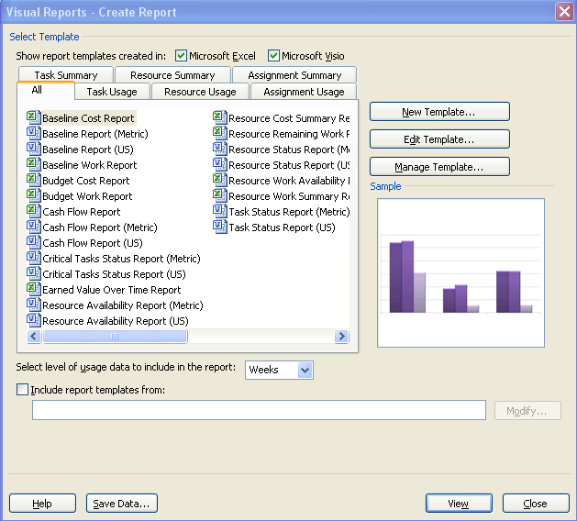

The report will generate by creating an OLAP cube and will open either Visio or Excel. In the generated Pivot Table select the data to be viewed on the report. Notice that the data viewed on the table can also be viewed in chart format.

Options are available for saving the generated OLAP cube or creating an Access database from the data by clicking the Save Data… button.

## Creating Visual Report Templates



Creating customized Visual report templates will allow inclusion of customized fields in Visual Reports. Standard templates can also be edited to include or exclude selected data.

**To edit a standard template:**

* Project 🡪 Visual Reports.
* Select any report.
* Click **Edit.**
* See instructions for field choices below.

**To create a new Visual report template:**

* Project 🡪 Visual Reports.
* Click **New Template.**

Visual Reports – New Template dialog box opens:

* Select Application: Visio or Excel.
* Select Data Type (destination for completed template).
  + Task Usage
  + Resource Usage
  + Assignment Usage
  + Task Summary
  + Resource Summary
  + Assignment Summary

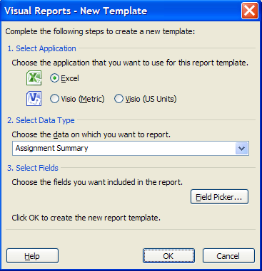

* Click on the **Field Picker** button.
* Add and remove fields from the report:
  + - * + Select fields to add to the report on the left side and click Add.
        + Select fields to remove from the report on the right side and click Remove.
* Click **OK** when field selection is completed.
* Click **OK** to create the new template.

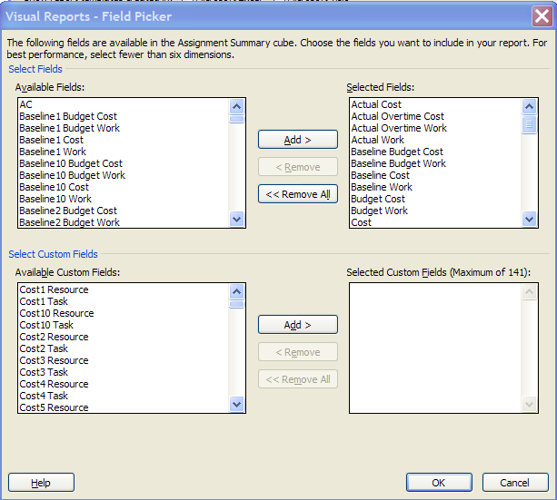

An OLAP cube will be generated and the will open in either Excel or Visio.

**To save the template:**

* **In either Excel or Visio click the Office** button 🡪 **Save As** .
* Give the template a name and leaving the template file extension of .xltx for Excel or .vsd for Visio.
* Click **OK** to create and save the template.

The following message will appear when an Excel template is created:

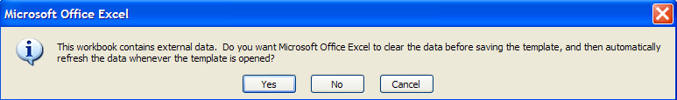

* + Click Yes to refresh or create new data when the template is run.

The new template will be added to the list of already available Visual Report templates. In the example below, a new template called New Visual Report Template was created.

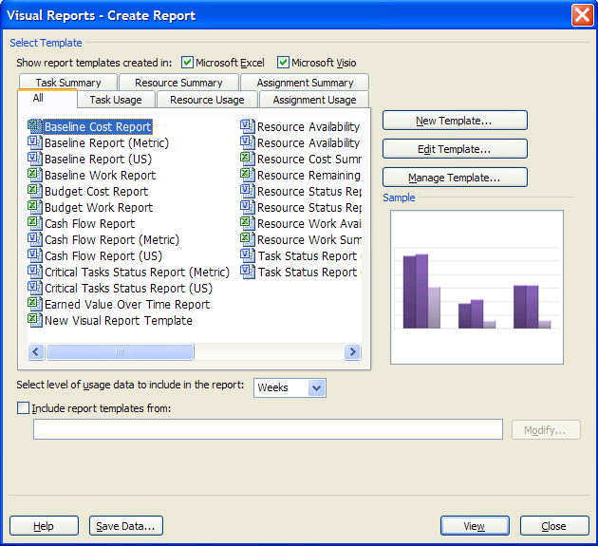

**To rename or delete an existing template:**

* Click the template to be renamed or deleted.
* Click **Manage Template.**
* Right-click the file.
* Select **Rename** or **Delete.**

## Practice: Viewing and Creating Visual Reports



*The Practice page is where you write detailed instructions for completing work listed as Exercises.*

*Type the Exercise Title and write a brief summary what the student will be doing in the exercise. Then list your ideas what they will be doing.*

*SAMPLE*

*In this practice you will create a Project Server Authentication profile and then configure the local cache settings in Project Professional 2007.*

*Exercise 1: Create Project Server Authentication Profile*

*In this exercise you will create Project Server authentication profile to connect to the Project Web Access site.*

Perform the following exercise on the PS07 virtual machine.

1. *From the* ***Start*** *menu, click* ***All Programs*** *🡪* ***Microsoft Office*** *🡪* ***Microsoft Office Tools*** *and click* ***Microsoft Office Project Server 2007 Accounts****.*
2. *In the* ***Project Server Accounts*** *dialog box, click* ***Add****.*
3. *In the* ***Account Properties*** *dialog box, and complete the following settings and click* ***OK****.*

|  |  |
| --- | --- |
| *Setting* | *Perform the following:* |
|  | |
| *Account Name* | *Type* ***Project Server*** |
| *Project Server URL* | *Type* ***http://epm/pwa*** |
| *When connecting* | *Select* ***Use Windows user account*** |
| *Set as default account* | *Select check box* |

# Lesson 4: Collaborating Project Information



Other applications can require the use of Project data in ways other than the .mpp file structure. To assist this need, Project 2010 has the ability to export data in multiple file formats.

In this lesson we will discuss:

1. Exporting project data
2. Creating a task list on a SharePoint site from Project 2010
3. Importing a task list from a SharePoint site

## Export Project Table to Excel



Project 2010 data can be exported to several file types. The export is initiated by saving the file into an alternate file format. These files formats include:

* Excel (.xls)
* PDF file
* XPS file
* Text (tab delimited) .txt
* CSV (comma delimited) .csv
* XML .xml format

**TIP:**  Look up field names for data export before starting the export wizard.

**To export data to Excel:**

* Open the file.
* **File 🡪 Save As.**
* Navigate to the location for the destination file.
* File Name: type the name for the destination file.
* Save as Type: **Excel Workbook (.xlsx or .xls).**
* Click **Save.**
* The export wizard will start. The first screen is an introduction screen.
* Click **Next** to move to the second screen, shown below.
* Choose either:
  + **Project Excel Template** which contains preselected fields from Tasks, Resources and Assignments
  + **Select Data:** This option will allow the user to select specific fields from Tasks, Resources or Assignments to be exported.
* Click **Next** to continue.

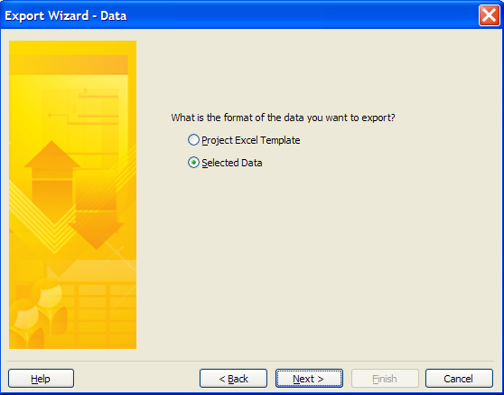

When data export settings are selected and saved, the object they are saved in is called a Map. Maps may be used to export date from MS Project or import data into a MS Project file.

* Choose New map to create your own export map or Use existing map to use a prebuilt map. We have chosen to create a new map. Click **Next** to continue.

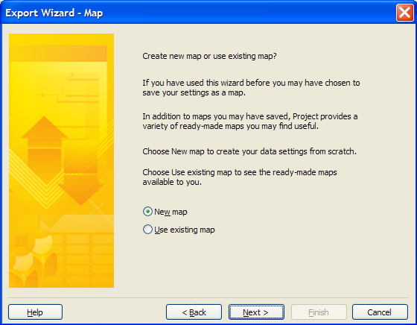

The screen for the next step is shown below. Select from the following choices:

* Data to be exported is taken from Task, Resource or Assignment data. Select one or all.
* Export includes headers – if selected, column headings will be included in the exported file.
* Click **Next** to continue.

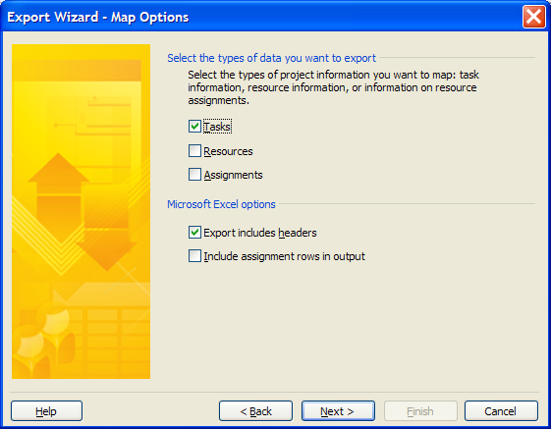

Use the Export Wizard – Task Mapping dialog box, shown below, to choose data to be included in the export.

**BEST PRACTICE:** Create a custom table with the data to be exported. Custom filters can also be applied to export maps. Customized fields can be included with the exported data.

* Destination worksheet name: name for the Excel worksheet tab.
* Export filter: filters can also be applied to export maps.
* Verify or edit how you want to map the data: Select which fields to include. Actual field names must be known for field selection. Pressing keyboard letters will jump to field names choices.
* Buttons for field selection:
  + Add All – will add all data fields to the export list
  + Clear All – will remove all fields entered in the export list
  + Insert Row – insert a new row into the export list above a selected field name
  + Delete Row – delete an existing selected row from the export list
  + Base on Table – select a standard or custom table. Data names will be added to the export list from the selected table.
* Add fields as necessary
* Click **Finish** to complete the export. The map settings will not be saved and will be for single use.   
    
   OR  
    
  Click **Next** to save the export map.

**TIP:**  When exporting all tasks the export will include summary, detail and milestone tasks. It would be useful to create a filter which would enable exporting of detail tasks only. Refer to the custom filter created in Module 8 for the instructions to create this filter.

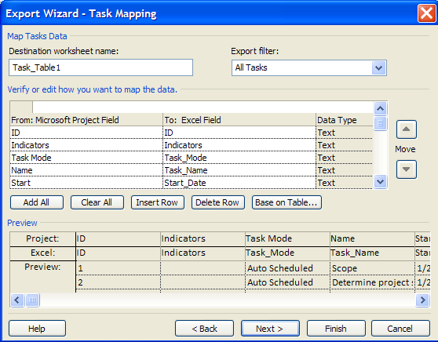

**NOTE:**

Files saved in older file formats will return the error message below if file Legacy options are not turned on.

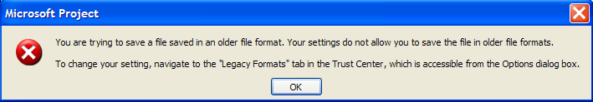

**To turn on the Legacy options:**

* **File 🡪 Options 🡪 Trust Center 🡪 Trust Center Settings 🡪Legacy Formats.**
* Select **Allow loading files with legacy or non-default file formats.**
* Click **OK** and **OK.**

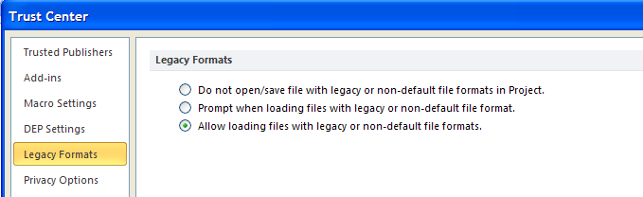

## Publish a Project to SharePoint List



**NOTE:**  SharePoint collaboration is available for Project 2010 Professional only.

If SharePoint is used with Project Professional 2010, you will be able to publish tasks to a variety of SharePoint sites. Tasks that have been published to a SharePoint site may be used to collect task progress data, which will be updated into a project schedule. Some requirements and restrictions for this functionality include:

* MS SharePoint Foundation 2010 or MS Project Server 2010 must be installed and implementated.
* User names for the SharePoint site must exactly match resource names on the resource sheet.
* Only human resources can be used.
* Only manually-scheduled tasks may be updated to the SharePoint site.
* Summary and detail task names must be unique for each project.
* Do not use special characters in summary tasks or task names.
* Only Finish-to-start dependencies are permitted.
* Do not use constraints on the tasks.

**To publish tasks to a SharePoint site:**

* **File 🡪 Save & Send.**
* **Sync with Tasks List.**
* Type the SharePoint site URL address.
* Click **Validate URL.**

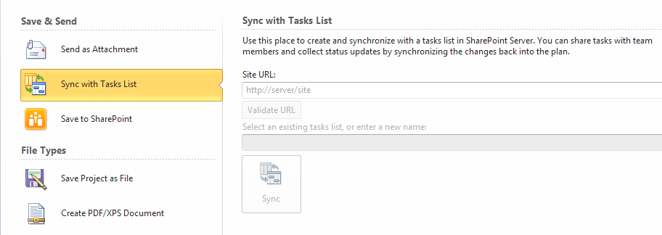

If a valid URL has been read and the user is valid:

* The *Select an existing tasks list or enter a new name* option becomes active.
* Type an existing task list or create a new task list (use project name).
* Click **Sync** to publish the tasks.

Possible problems that could occur during sync are:

* Invalid user or lack of permission to update a task list.
* Resource name does not match SharePoint user name.
* Automatically scheduled tasks were used.
* Special characters were used.
* Tasks contain constraints.
* Tasks use Start-to-start or Finish-to-finish relationships.
* Duplicate task names – summary and detail.

## Import SharePoint List into Project



Existing task lists created in SharePoint can be imported into a Project Professional 2010 schedule. Some of the requirements for this type of import are:

* Field names in the SharePoint list must match field names in Project 2010.
* Field types must match in both SharePoint and Project 2010.
* No special characters can be used in the data.
* The task list will be appended to the end of the existing project schedule or can be used to add tasks to a new project schedule.
* When tasks are imported, they are considered new tasks to Project 2010. Therefore, Project 2010 options will apply.
* Custom columns can be used but they must pre-exist in Project 2010 prior to the import.

**To import a SharePoint list into Project 2010:**

* **File 🡪 Save & Send.**
* **Sync with Tasks List.**
* Type the SharePoint site URL address.
* Click **Validate URL**.



If a valid URL has been read and the user is valid:

* The Select an existing task list or enter a new name option becomes active.
* Type an existing task list name or create a new task list (use project name).
* Click **Sync** to publish the tasks.

**NOTE:** The import process can also be used for importing task progress data entered for the tasks on the SharePoint site.

## Video Demo: Working with SharePoint



*Nothing to write here*

## Practice: Exporting Project Data to Excel



*The Practice page is where you write detailed instructions for completing work listed as Exercises.*

*Type the Exercise Title and write a brief summary what the student will be doing in the exercise. Then list your ideas what they will be doing.*

*SAMPLE*

*In this practice you will create a Project Server Authentication profile and then configure the local cache settings in Project Professional 2007.*

*Exercise 1: Create Project Server Authentication Profile*

*In this exercise you will create Project Server authentication profile to connect to the Project Web Access site.*

Perform the following exercise on the PS07 virtual machine.

1. *From the* ***Start*** *menu, click* ***All Programs*** *🡪* ***Microsoft Office*** *🡪* ***Microsoft Office Tools*** *and click* ***Microsoft Office Project Server 2007 Accounts****.*
2. *In the* ***Project Server Accounts*** *dialog box, click* ***Add****.*
3. *In the* ***Account Properties*** *dialog box, and complete the following settings and click* ***OK****.*

|  |  |
| --- | --- |
| *Setting* | *Perform the following:* |
|  | |
| *Account Name* | *Type* ***Project Server*** |
| *Project Server URL* | *Type* ***http://epm/pwa*** |
| *When connecting* | *Select* ***Use Windows user account*** |
| *Set as default account* | *Select check box* |

# Summary



Lack of communicate during project execution will result in project failure. Project 2010 provides a variety of reports to fulfill your reporting needs. Customizing reports allow you to add customized data and increase report effectiveness. Exporting data to other applications also allows other applications to use Project 2010 data in alternate file formats.

In this module we discussed:

* Print options and settings
* Standard and customized reports
* Visual reports
* Exporting project data
* Publishing and importing project data to SharePoint lists